Assignment-2.1
E.VAISHNAVI
2303A51943
B-27
Task 1: Statistical Summary for Survey Data Scenario:
You are a data analyst intern working with survey responses stored as
numerical lists.
- Task:
Use Google Gemini in Colab to generate a Python function that reads a list
of numbers and calculates the mean, minimum, and maximum values.
Output:
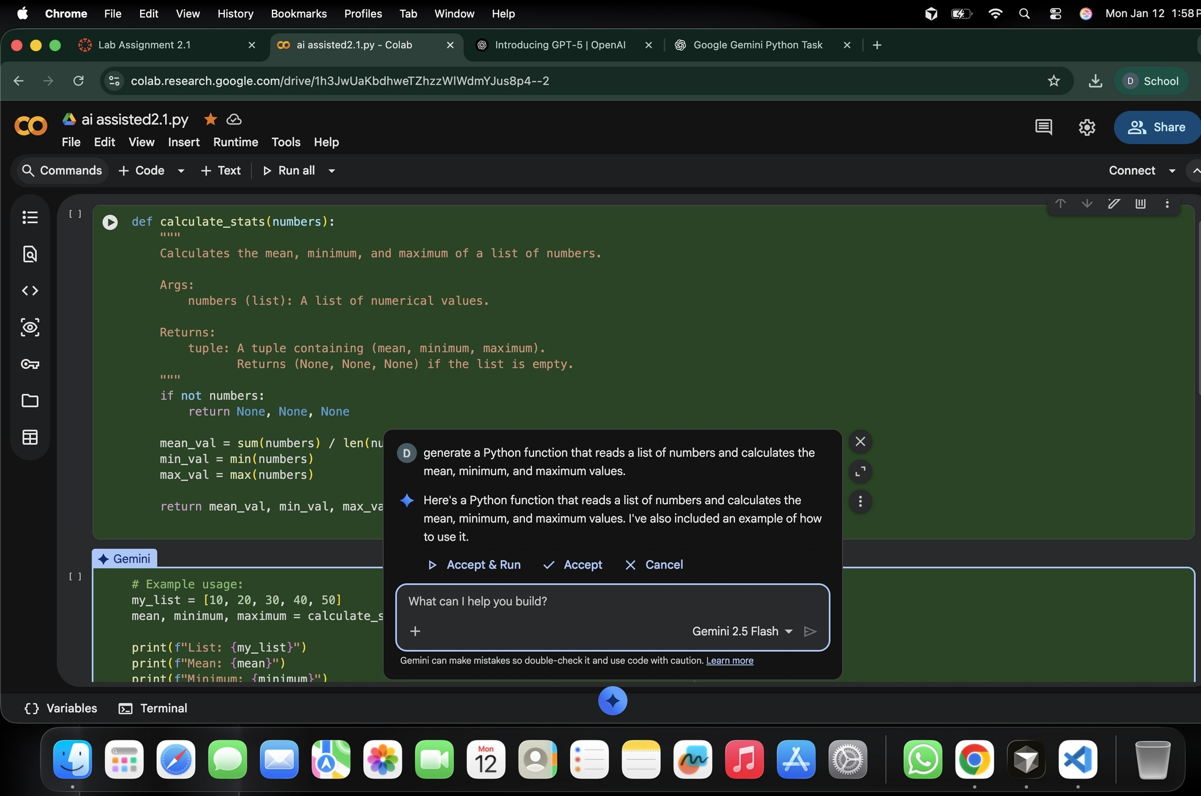
Screenshot of Gemini prompt and result

Correct Python function Output shown in Colab
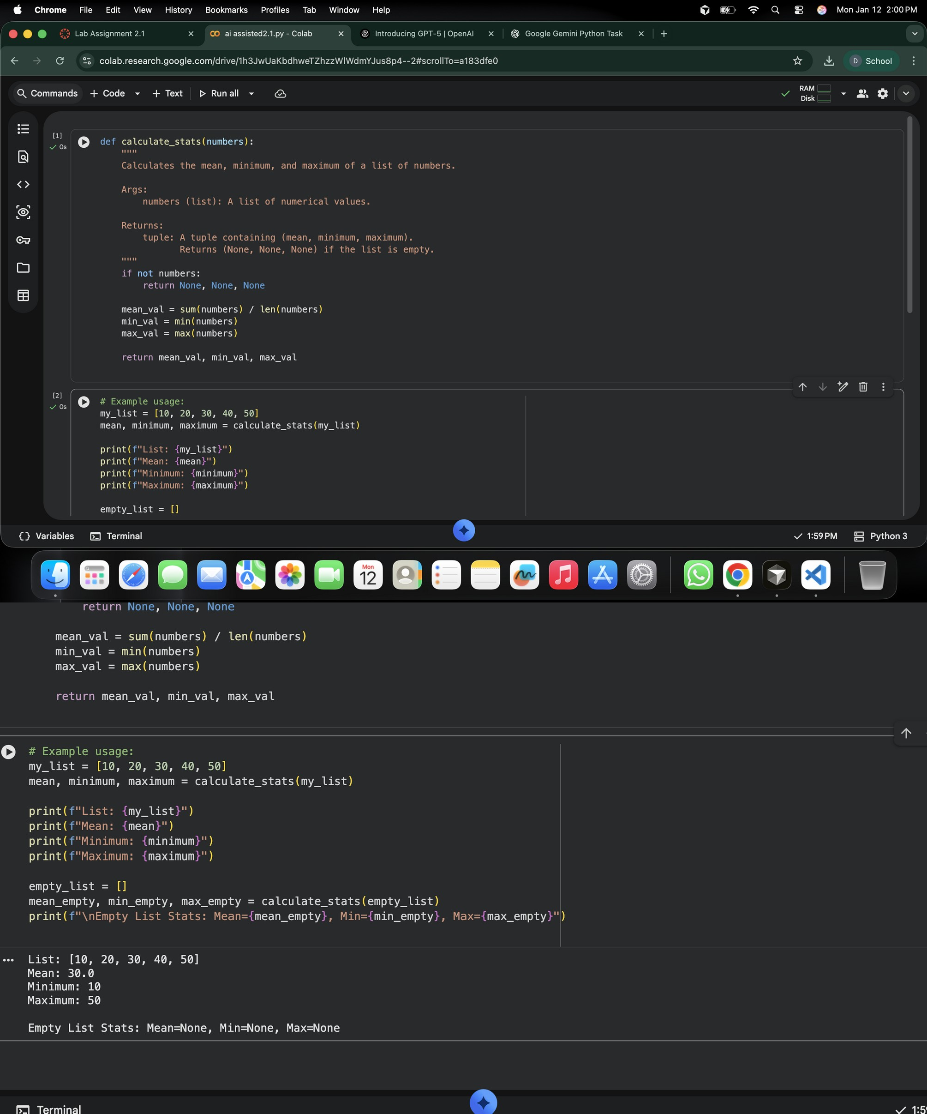

Task 2: Armstrong Number – AI Comparison
- Scenario:
You are evaluating AI tools for numeric validation logic.
- Task:
Generate an Armstrong number checker using Gemini and GitHub
Copilot.
Compare their outputs, logic style, and clarity.
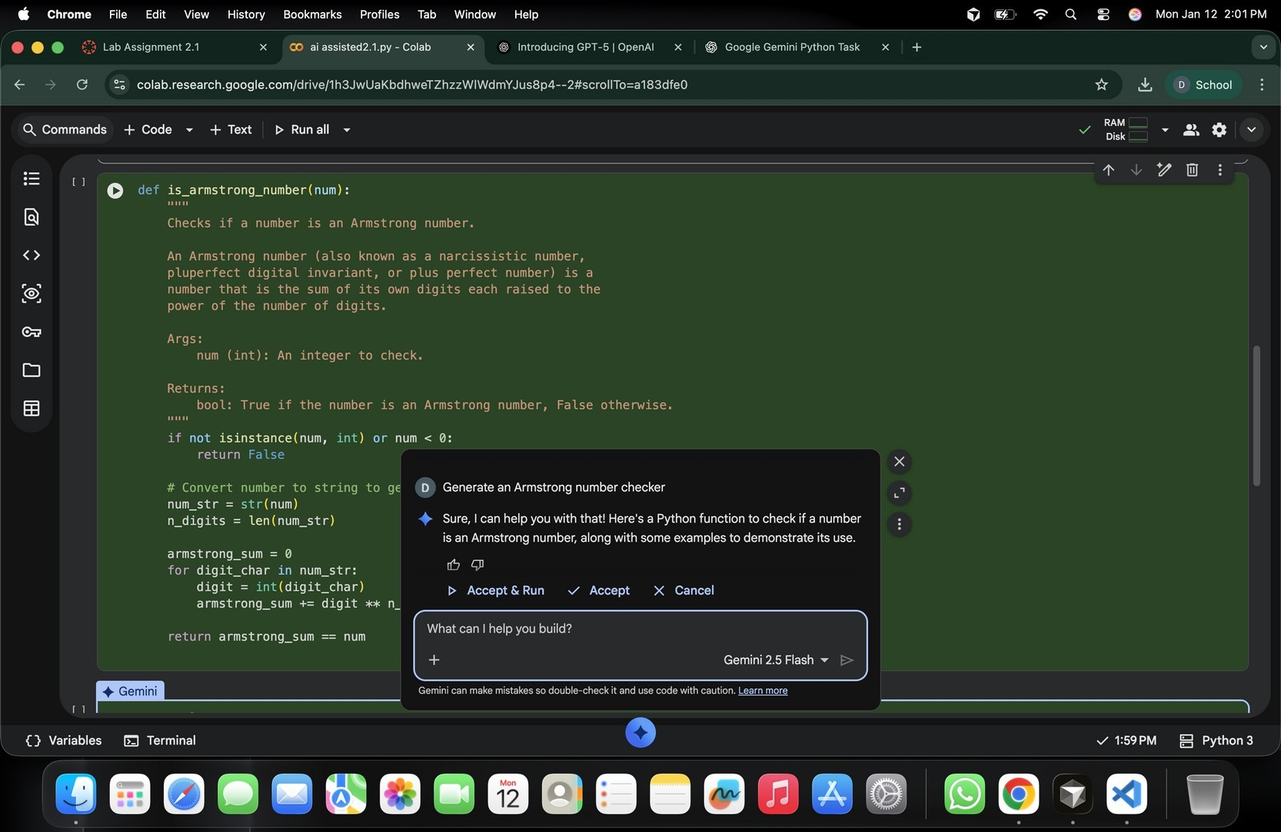

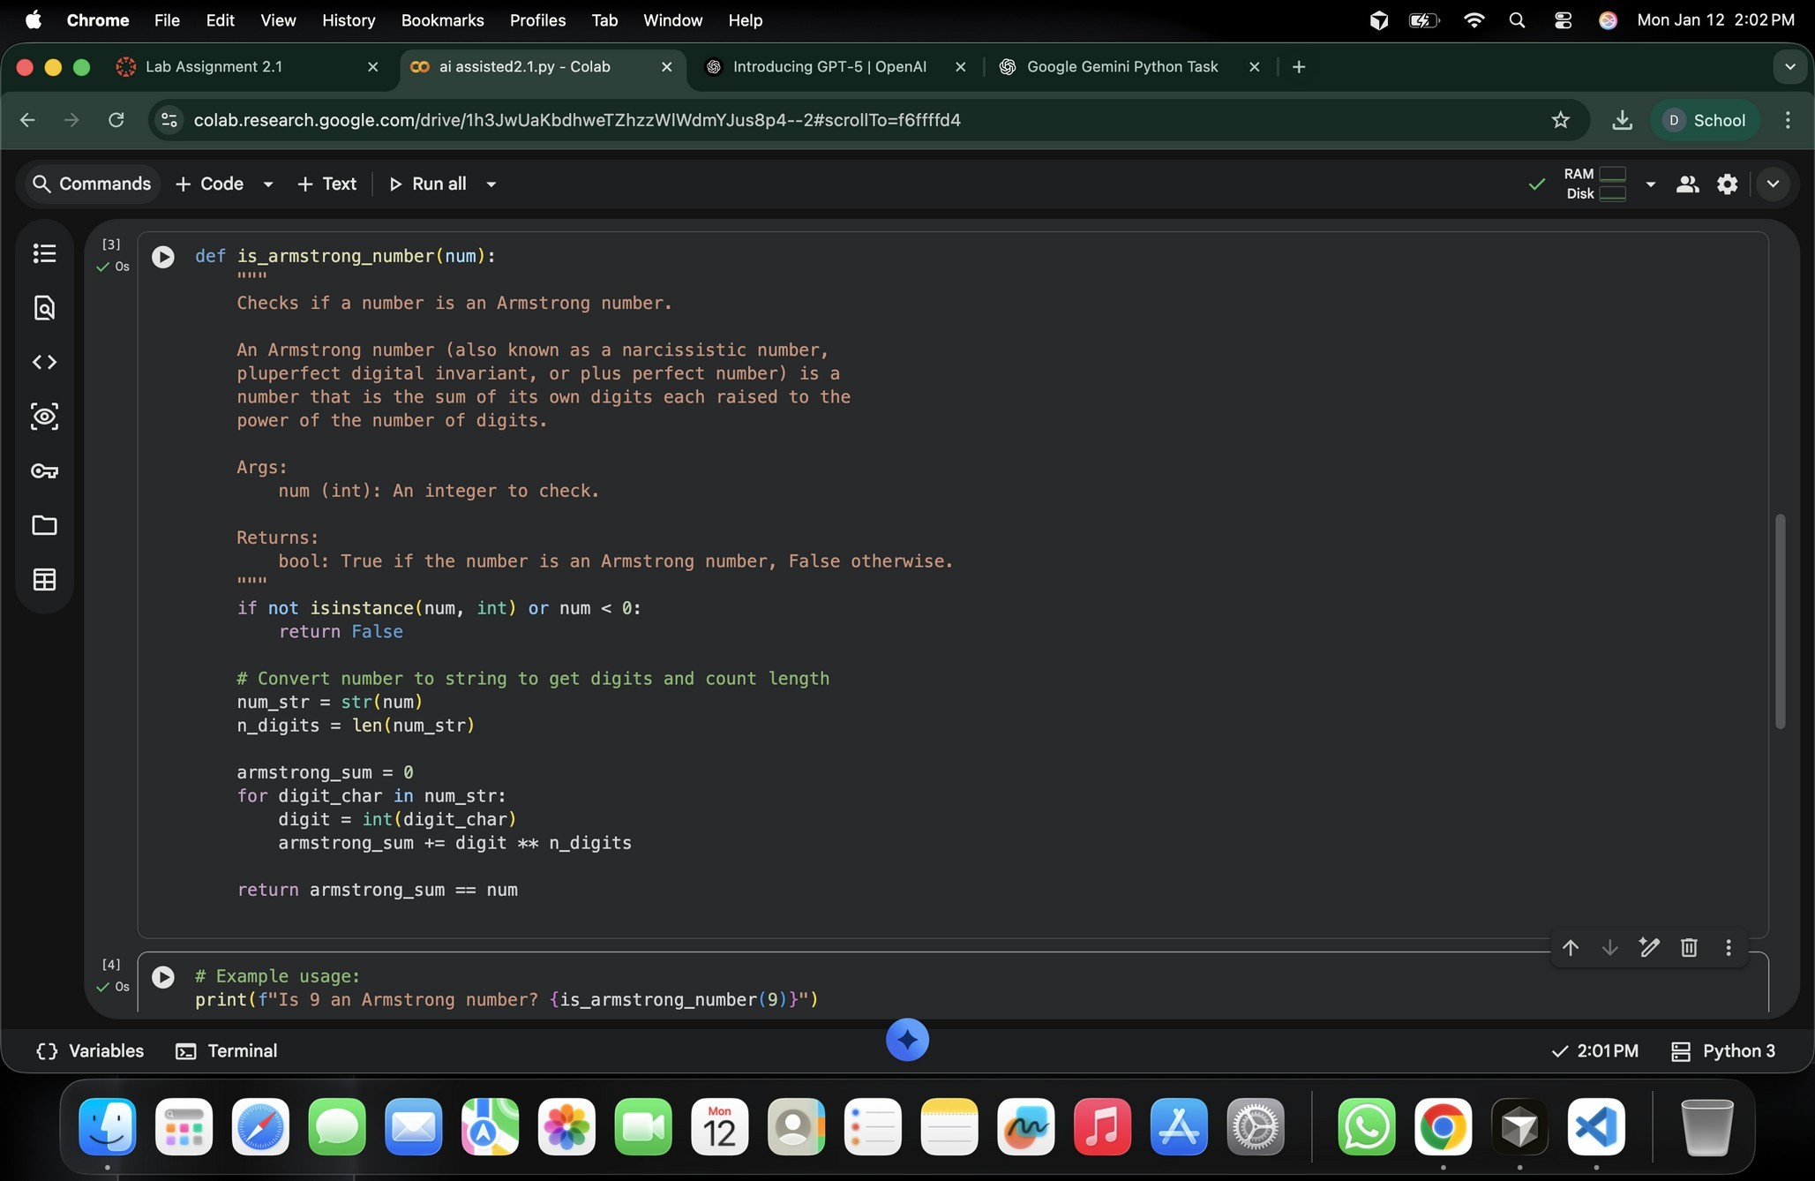

Using vs and GitHub copilot
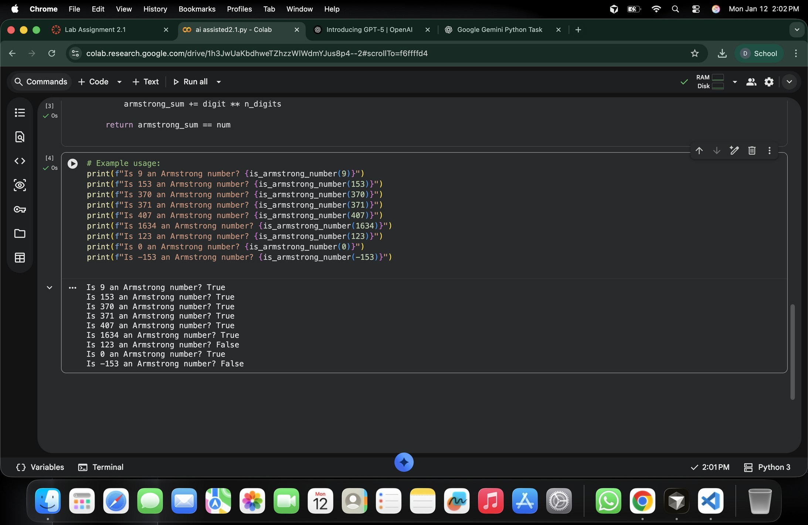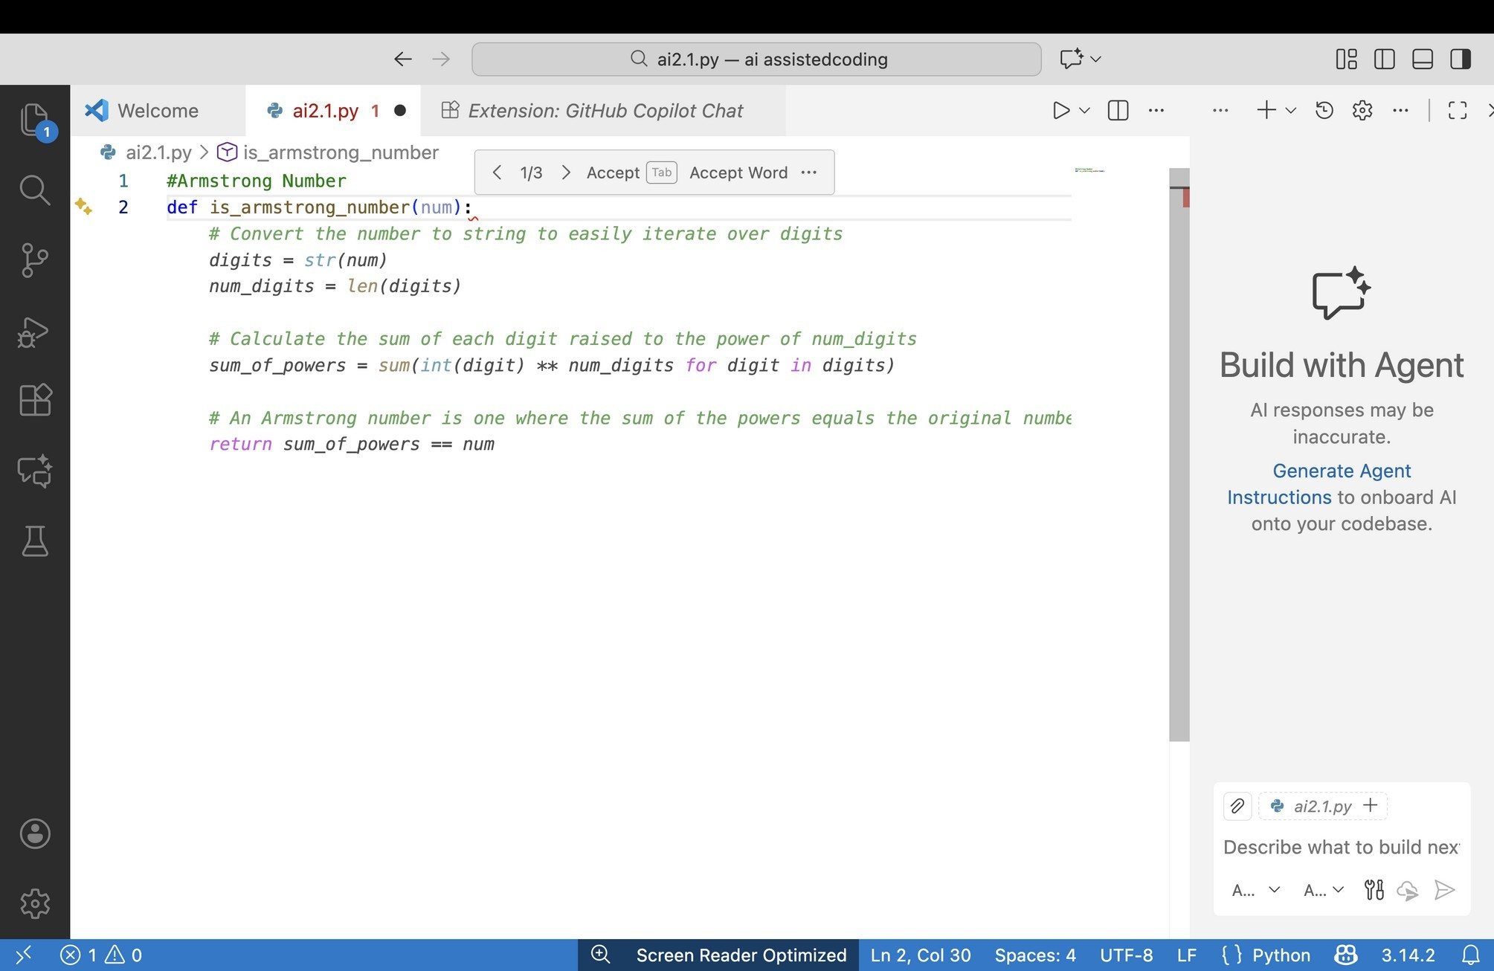

Task 3: Leap Year Validation Using Cursor AI
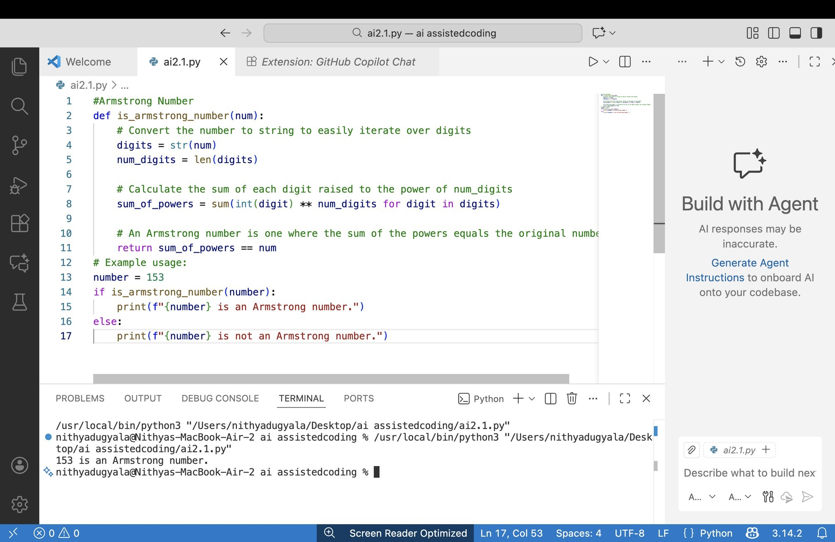
- Scenario:
You are validating a calendar module for a backend system.
- Task:
Use Cursor AI to generate a Python program that checks whether a given
year is a leap year.

Use at least two different prompts and observe changes in code.
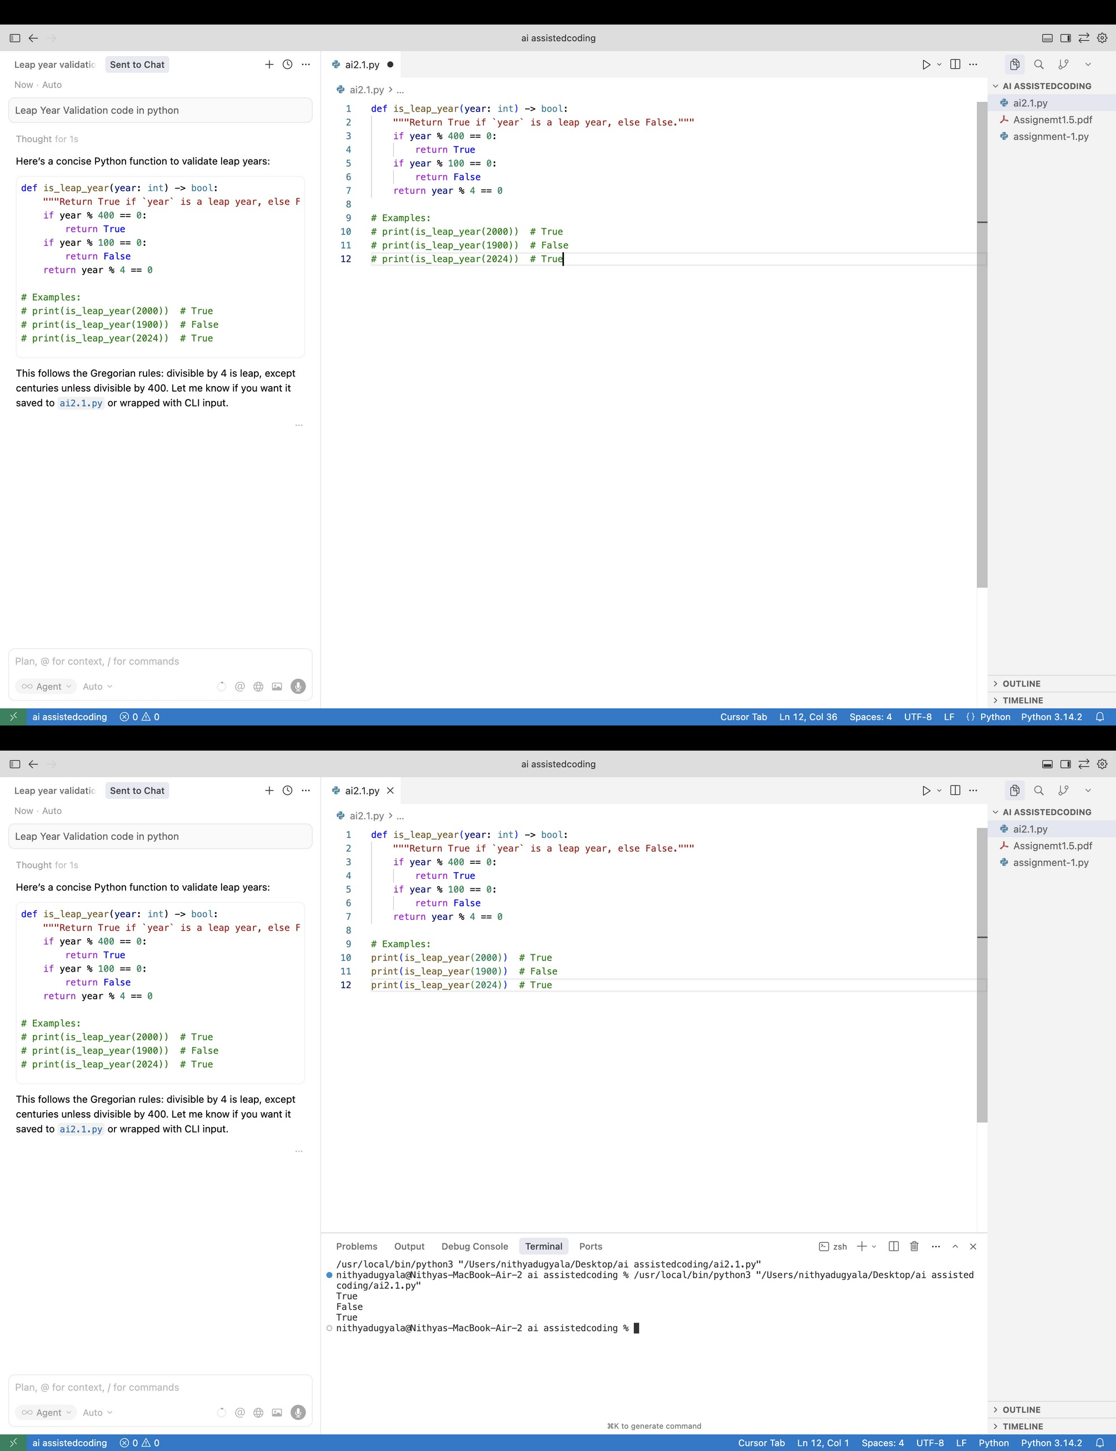

Other prompt:
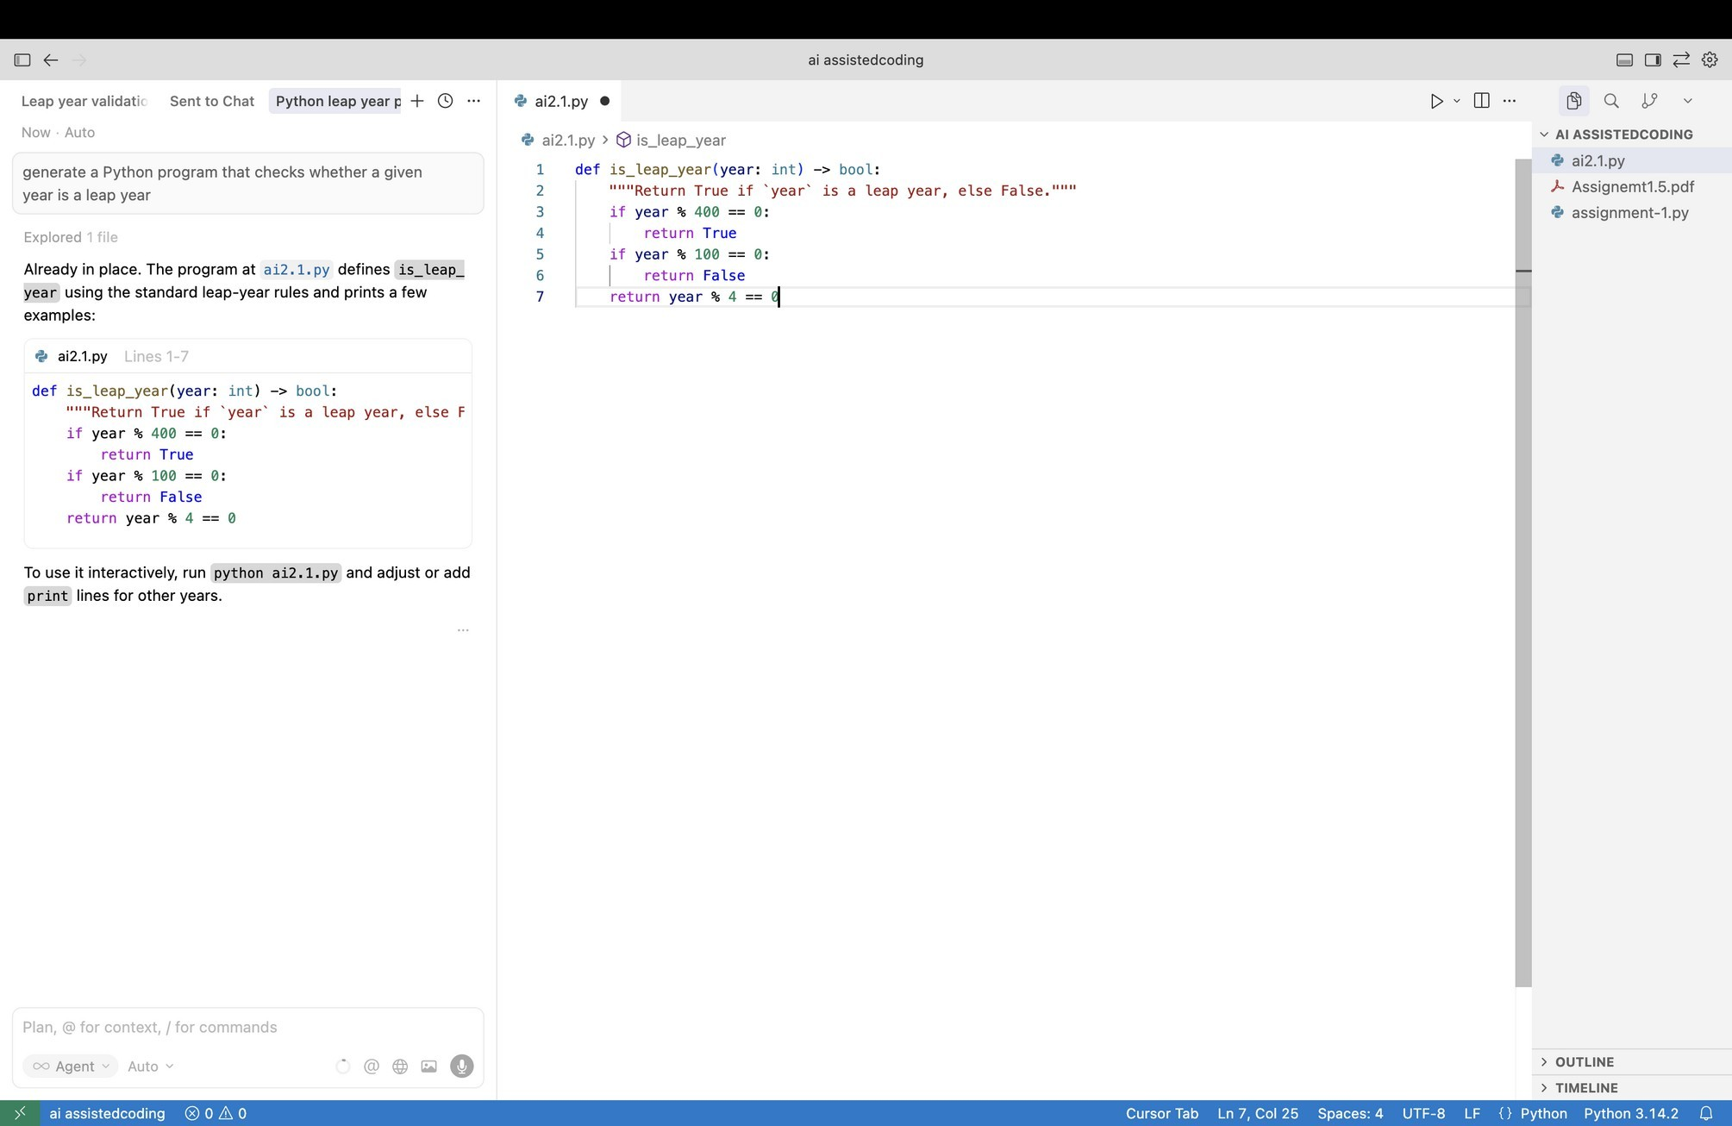

task 4: Student Logic + AI Refactoring (Odd/Even Sum)
- Scenario:
Company policy requires developers to write logic before using AI.
- Task:
Write a Python program that calculates the sum of odd and even numbers
in a tuple, then refactor it using any AI tool. Expected Output:
- Original code
- Refactored code
- Explanation of improvements
